Images Inside the Exhibit Tent

Stop 1
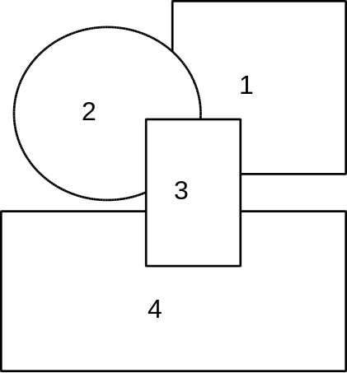
1. Modern photograph of Monticello
2. Thomas Jefferson by Rembrandt Peale, 1805
3. Thomas Jefferson to Meriwether Lewis
4. Detail of 3

Stop 2
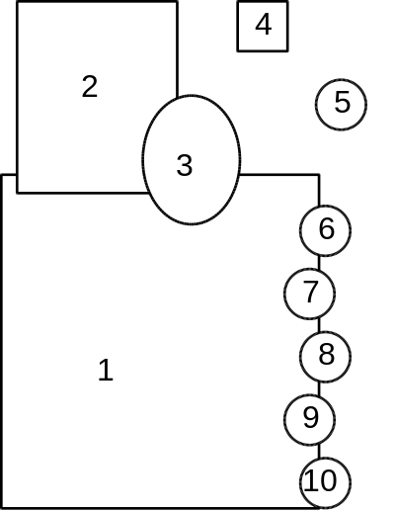
1. Philadelphia 1799 engraving by W. Birch
2. Harpers Ferry 1803 engraving SOURCE?
3. Meriwether Lewis by Charles Wilson Peale, 1807
4. Compass
5. Chronometer
6. Robert Patterson SOURCE AND DATE?
7. Charles Willson Peale “The Artist in his museum.” 1822
8. Dr. Benjamin Rush Charles Willson Peale 1818
9. Dr. Caspar Wistar SOURCE AND DATE?
10. Dr. Benjamin Smith Barton SOURCE AND DATE?
Stop 3
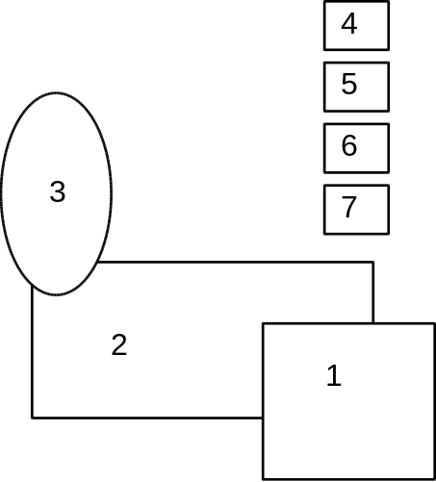
1. 1804 Samuel Clark map of Louisiana
2. 1814 William Clark map of the track across North America
3. William Clark by Charles Wilson Peale, 1807
4. 1803 United States flag
5. Union Jack
6. French Tricolor
7. Spanish flag

Stop 4
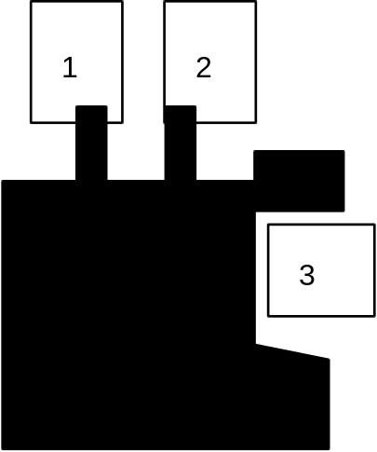
1. Meriwether Lewis by Charles Wilson Peale, 1807
2. William Clark by Charles Wilson Peale, 1807
3. Trail map detail, NPS
4. Corps images by Michael Haynes
Stop 5
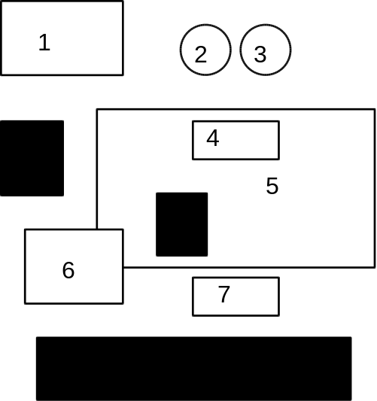
1. Michael Haynes
2. Peace Medal obverse
3. Peace Medal reverse
4. Engraving from Matthew Carey edition of Journals of Patrick Gass, 1810
5. Trail map detail, NPS
6. Image from Time magazine, by Lon Blum(?)
7. Keelboat sketch from Journals of William Clark
8. Corps images by Michael Haynes

Stop 6
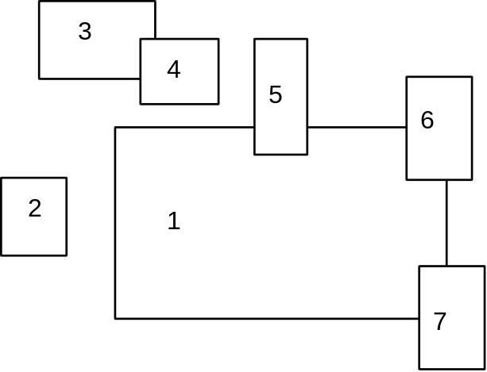
1. Trail map detail, NPS
2. Modern photograph of Fort Clatsop
3. Charles M. Russell, DATE AND TITLE?
4. Charles M. Russell, DATE AND TITLE?
5. Olaf Seltzer, DATE AND TITLE?
6. Robert F. Morgan, 1988 TITLE?
7. Engraving from CBJ Fevret de Saint Memin, SOURCE DATE AND ARTIST?
Stop 7
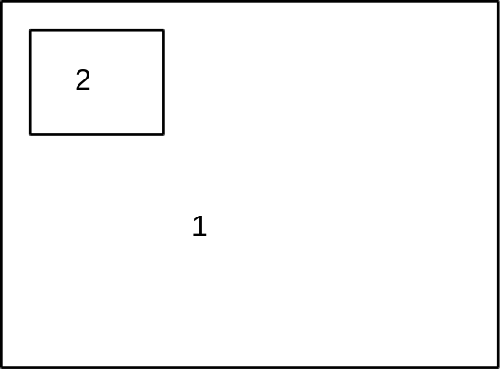
1. Karl Bodmer, “View of the Missouri River with the Bear Pass Mountains in the distance” DATE?
2. Modern photograph of bends in the Missouri river

Stop 8
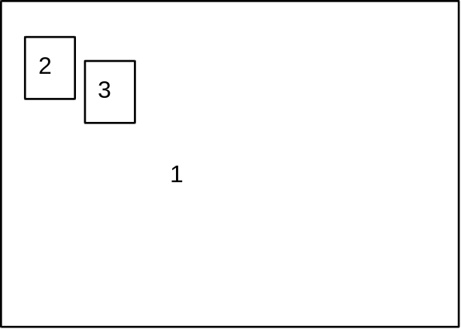
1. Karl Bodmer, “The Stone Walls of the Missouri” 1833
2. Modern photograph of Missouri Breaks
3. Modern photograph of Missouri Breaks

Stop 9
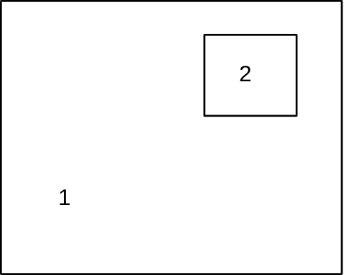
1. Karl Bodmer, “Buffalo and Elk on the Upper Missouri” DATE?
2. Karl Bodmer, DATE AND TITLE?
Stop 10
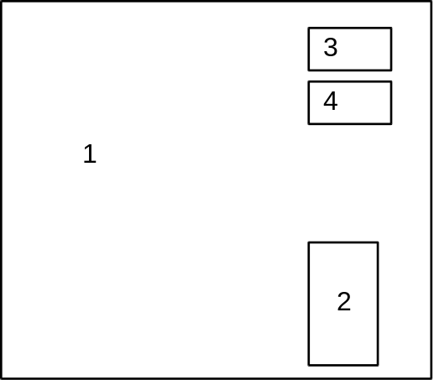
1. Karl Bodmer, DATE AND TITLE?
2. Karl Bodmer, Assiniboin Medicine Shrine
3. George Catlin, DATE AND TITLE?
4. George Catlin, DATE AND TITLE?

Stop 11
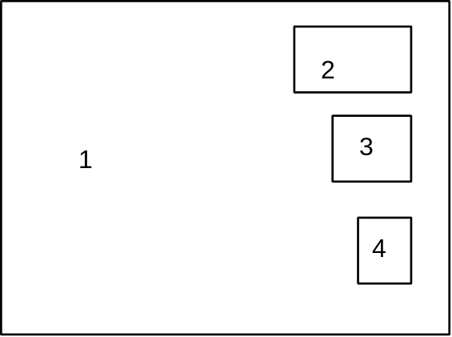
1. Karl Bodmer, Sioux Camp
2. No Two Horns, Hunkpapa, “The Winter Count” DATE?
3. Karl Bodmer, “Summer encampment of the Piegans” DATE?
4. George Catlin, DATE AND TITLE?
Stop 12
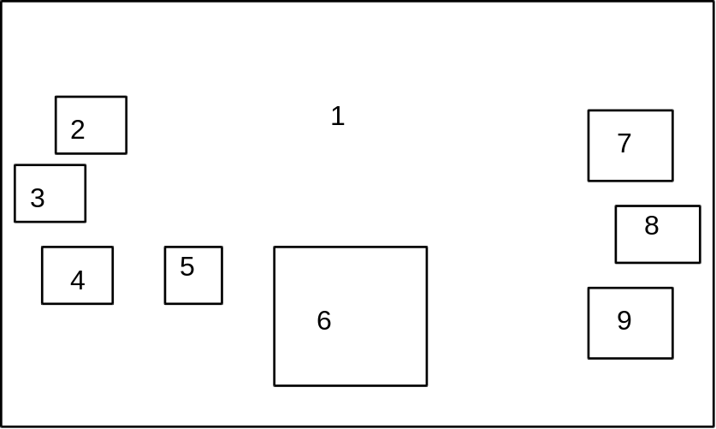
1. Photograph of interior of a reproduction earth lodge
2. George Catlin, DATE AND TITLE?
3. Sitting Rabbit, 1804 TITLE?
4. Karl Bodmer, DATE AND TITLE?
5. Karl Bodmer, DATE AND TITLE?
6. Karl Bodmer, Interior of a Mandan earth lodge
7. Karl Bodmer, “Bison Dance of the Mandan Indians” DATE?
8. Photograph of reconstructed Hidatsa earth lodge
9. Karl Bodmer, ?DeTroloviand? Like-A-Fishhook DATE AND TITLE?

Stop 13
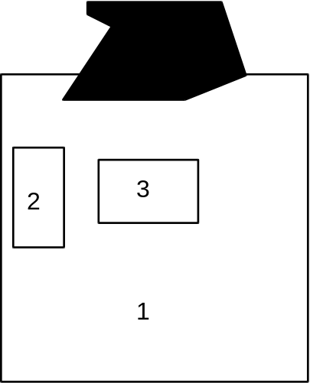
1. Karl Bodmer, “Mandan Shrine” DATE?
2. Karl Bodmer, Assiniboin Burial Scaffold
3. George Catlin, Pipestone quarry on the Coteau Des Praries, Minnesota, 1836-7
4. Pipes and bowls by Karl Bodmer
Stop 14
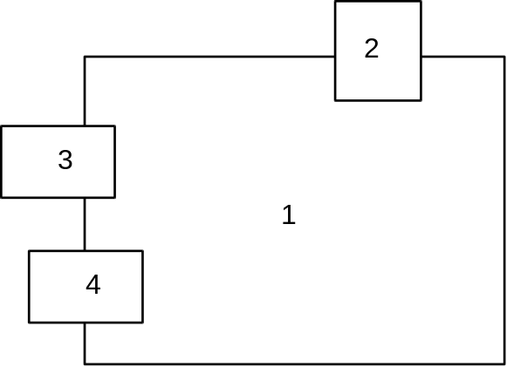
1. Charles M. Russell, 1905, Lewis and Clark meeting the Indians of the Lower Columbia
2. SOURCE DATE AND TITLE?
3. Paul Kane, DATE AND TITLE?
4. Paul Kane, DATE AND TITLE?

Stop 15
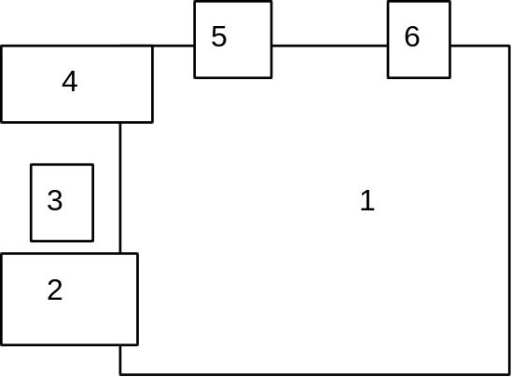
1. Paul Kane, DATE AND TITLE?
2. Paul Kane, DATE AND TITLE?
3. SOURCE DATE AND TITLE?
4. SOURCE DATE AND TITLE?
5. Paul Kane, Woman’s Name “Caw-wacham” Cowlitz Tribe Died May or June 1847. * See Paul Kane, The Columbia Wanderer, attached
6. SOURCE DATE AND TITLE?
Stop 16
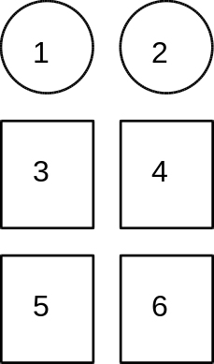
1. Peace Medal obverse
2. Peace Medal reverse
3. Meriwether Lewis by Charles Wilson Peale, 1807
4. William Clark by Charles Wilson Peale, 1807
5. Photograph, SOURCE AND DATE?
6. George Catlin, “Mandan Chief Black Moccasin” DATE?

Other Images inside the Exhibit Tent
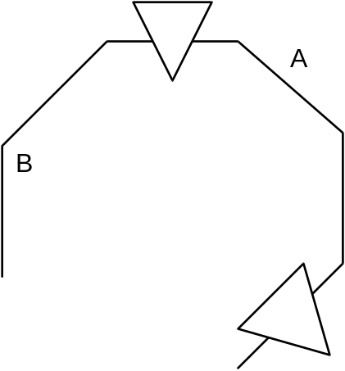
A. Photograph of Gates of the Mountains
B. Trail Map, NPS

